Previous Question 2020 – 2021

1 [A.] What distinguishes a host from an end system? Provide examples of various end systems. Would a web server be considered an end system? How are end systems related to hosts, and what distinguishes clients from servers within this context? [03 marks]
[B.] HFC, DSL, and FTTH are all used for residential access. For each of these access technologies, provide a range of transmission rates and comment on whether the transmission rate is shared or dedicated. [02 marks]
[C.] Suppose users share a 2 Mbps link. Also suppose each user transmits continuously at 1 Mbps when transmitting, but each user transmits only 20 percent of the time. [04 Marks ]
a. When circuit switching is used, how many users can be supported?
b.' For the remainder of this problem, suppose packet switching is used. Why will there be essentially no queuing delay before the link if two or fewer users transmit at the same time? Why will there be a queuing delay if three users transmit at the same time?
c. Find the probability that a given user is transmitting.
d. Suppose now there are three users. Find the probability that at any given time, all three users are transmitting simultaneously. Find the fraction of time during which the queue grows.
[D.] In this scenario, we are considering the transmission of real-time voice from Host A to Host B over a packet-switched network using VoIP. Host A converts the analog voice signal into a digital bitstream at a rate of 64 kbps. Host A then collects the bits into packets, each containing 56 bytes. There is a single link between Hosts A and B with a transmission rate of 10 Mbps and a propagation delay of 10 milliseconds. As soon as Host A forms a packet, it immediately sends it to Host B. Upon receiving the entire packet, Host B converts the packet's bits back into an analog signal. What is the total time that elapses from the moment a bit is created (from the original analog signal at Host A) until it is decoded (as part of the analog signal at Host B)? 03 marks
[E.]. What are an application-layer message, a transport-layer segment, a network-layer datagram, a link-layer frame? 02 marks
2 (A) router receives a packet with the destination address 201.24.67.32. Show how the router finds he network address of the packet02 marks
চলো ধাপে ধাপে বুঝাই — 2 marks-এর জন্য সরলভাবে।

Step 1: Determine the subnet mask
- ধরো router-এর interface এ network = 201.24.67.0/24
- Subnet mask = 255.255.255.0

Step 2: Perform bitwise AND
- Network address বের করার জন্য destination IP AND subnet mask করি
Destination IP: 201.24.67.32
Subnet mask: 255.255.255.0
201.24.67.32 → 11001001.00011000.01000011.00100000
255.255.255.0 → 11111111.11111111.11111111.00000000
Bitwise AND → 11001001.00011000.01000011.00000000

Step 3: Convert back to decimal
11001001.00011000.01000011.00000000 → 201.24.67.0

✅ Result
- Network address = 201.24.67.0

Summary (marks-oriented):
- Router ANDs destination IP with subnet mask → network address
- Here: 201.24.67.32 AND 255.255.255.0 = 201.24.67.0
[B.] What is CIDR, and how can you extract block information from a given IP address? 03 marks
Cholo sohoje bujhi:

1️⃣ What is CIDR?
CIDR = Classless Inter-Domain Routing
- এটি একটি IP addressing scheme যা class-based addressing (Class A/B/C) এর সমস্যাগুলো সমাধান করে।
- CIDR ব্যবহার করে আমরা flexible block sizes তৈরি করতে পারি, যেমন /24, /22, /30 ইত্যাদি।
- Syntax:
IP_address / prefix_length
যেখানে prefix_length = number of bits for the network part।
Example:
192.168.1.0/24
- /24 মানে network-এর প্রথম 24 bit ঠিকানা নির্দেশ করে।
- অবশিষ্ট 8 bit = host addresses → 2^8 = 256 addresses
Advantages:
- ঠিকানার space efficient ব্যবহার
- রাউটিং টেবিল ছোট রাখা সম্ভব
- Subnetting এবং supernetting সহজ

2️⃣ How to extract block information from a given IP address?
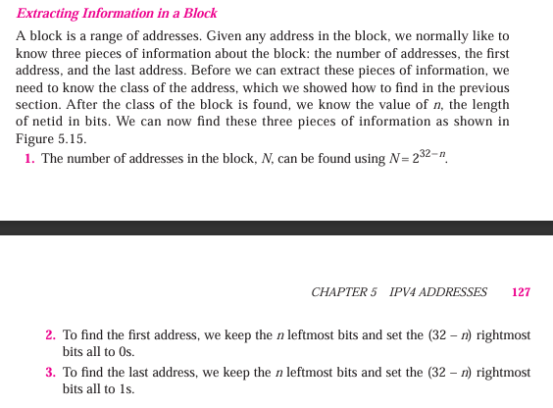

[C.] Assume a company has three offices: Central, East, and West. The Central office is connected to the East and West offices via private, point-to-point WAN lines. The company is granted a block of 64 addresses with the beginning address 70.12.100.128/26. The management has decided to allocate 32 addresses for the Central office and divides the rest of addresses between the two other offices. Finally the the block with its ip address 04 marks
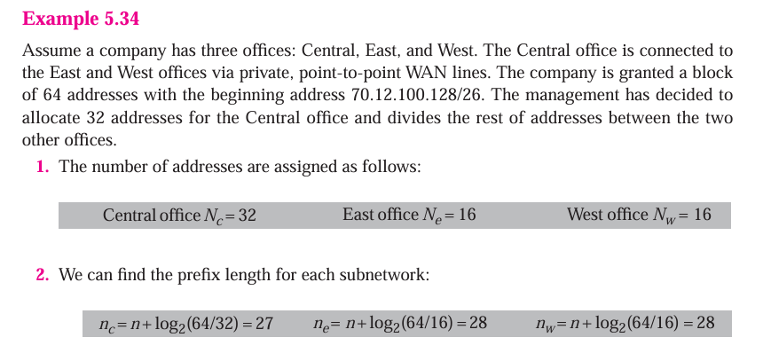
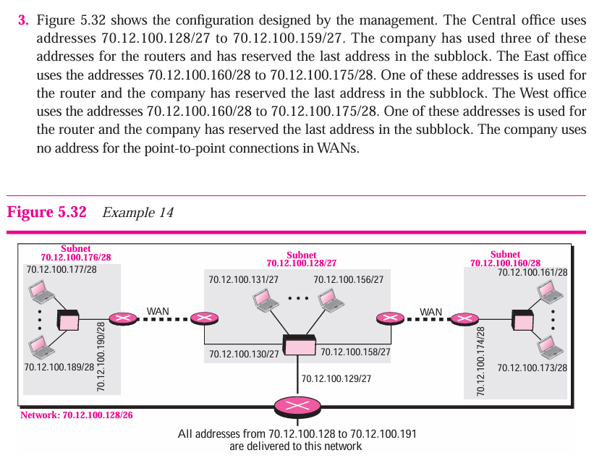

মূল ধরণ (বিস্তারিত)
দেওয়া ব্লক: 70.12.100.128/26
- মোট ঠিকানা = 64 (2^{32-26} = 2^6 = 64)
- ব্লকের রেঞ্জ: 70.12.100.128 … 70.12.100.191

1) Central — 32 ঠিকানা
- 32 ঠিকানার জন্য ব্লক সাইজ = 32 = 2^5 → prefix = 32 - 5 = 27 → /27
- /26 ব্লককে দুইটি /27-এ ভাগ করা যায়:
  - প্রথম /27: 70.12.100.128/27 → addresses .128–.159 (32 addr)
  - দ্বিতীয় /27: 70.12.100.160/27 → addresses .160–.191 (32 addr)
- তাই Central-কে আমরা প্রথম /27 দিই:
  - Network: 70.12.100.128/27
  - Netmask: 255.255.255.224
  - Address range: 70.12.100.128 (network) → 70.12.100.159 (broadcast)
  - Usable hosts: 70.12.100.129 … 70.12.100.158 → 30 usable addresses

2) East ও West — বাকি 32 ঠিকানা ভাগ করা
- বাকি ব্লক = 70.12.100.160/27 (32 addresses: .160–.191)
- সহজ সমতা: East এবং West—প্রতিটিকে 16 addresses করে দেওয়া যায়।
- 16 ঠিকানা হলে 2^4 → prefix = 32 - 4 = 28 → /28 (mask 255.255.255.240)
- তাই /27 (32 addr) কে দুইটি /28 (16 addr each) এ ভাগ করা:
East:
  - Network: 70.12.100.160/28
  - Range: 70.12.100.160 → 70.12.100.175
  - Usable hosts: 70.12.100.161 … 70.12.100.174 → 14 usable
West:
  - Network: 70.12.100.176/28
  - Range: 70.12.100.176 → 70.12.100.191
  - Usable hosts: 70.12.100.177 … 70.12.100.190 → 14 usable

সারসংক্ষেপ টেবিল
Office | Network (CIDR) | Mask | Address range | Usable hosts (count)
Central | 70.12.100.128/27 | 255.255.255.224 | 70.12.100.128 – 70.12.100.159 | 70.12.100.129–.158 (30)
East | 70.12.100.160/28 | 255.255.255.240 | 70.12.100.160 – 70.12.100.175 | 70.12.100.161–.174 (14)
West | 70.12.100.176/28 | 255.255.255.240 | 70.12.100.176 – 70.12.100.191 | 70.12.100.177–.190 (14)

[D.] An ISP is granted a block of addresses starting with 150.80.0.0/16. The ISP wants to distribute these blocks to 2600 customers as follows: 05 marks
a. The first group has 200 medium-size businesses; each needs approximately 128 addresses.
b. The second group has 400 small businesses; each needs approximately 16 addresses.
c. The third group has 2000 households; each needs 4 addresses.

3 [A] In classless addressing, we know the first and the last address in the block. Can we find the prefix length? If the answer is yes, show the process and give an example. 03 marks
[B] We noted that network layer functionality can be broadly divided into data plane functionality and control plane functionality. What are the main functions of the data plane? Of the control plane? 03 marks
চলো সহজভাবে ধাপে ধাপে বুঝি।

Network Layer Functionality
Network layer কাজকে দুই ভাগে ভাগ করা যায়:
- Data Plane (Forwarding Plane)
- Control Plane (Routing Plane)

1️⃣ Data Plane (Forwarding Plane)
Main function:
- Packets কে input থেকে output interface এ পাঠানো (forwarding)
- প্রতিটি router বা switch এই কাজ করে।
Key activities:
- Lookup destination address in the forwarding table
- Determine outgoing interface
- Forward packet to the next hop
- Implement QoS, filtering, and encapsulation if needed
Sohoje:
“Data plane হলো network-এর highway, যা আসল traffic (packets) কে চলাচল করায়।”

2️⃣ Control Plane (Routing Plane)
Main function:
- Network topology এবং forwarding decision তৈরি করা
- Routing protocols, neighbor discovery, topology updates ইত্যাদি control plane এ হয়।
Key activities:
- Build and maintain routing tables
- Exchange routing information with other routers
- Update forwarding tables based on network changes
Sohoje:
“Control plane হলো network-এর brain, যা সিদ্ধান্ত নেয় কোন পথ দিয়ে packets যাবে।”
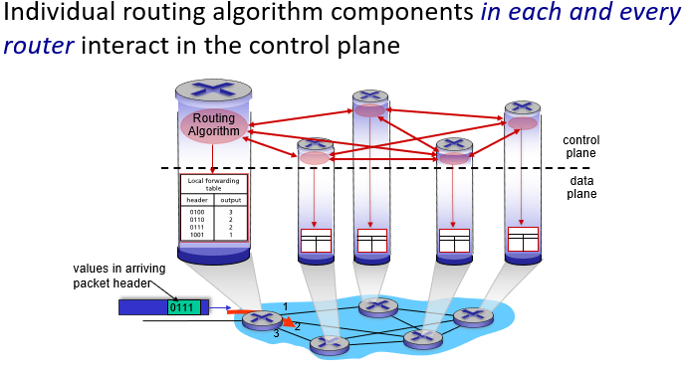

🔹 সংক্ষিপ্ত ফারাক:
Plane | Main Function
Data Plane | Forward packets from input to output
Control Plane | Determine network paths and update routing tables

✅ Marks-oriented answer (3 marks)
- Data plane: Forward packets using the forwarding table
- Control plane: Determine paths using routing protocols and update forwarding table
- Short note: Data plane = highway, Control plane = brain

[C.] Compare and contrast the properties of a centralized and a distributed routing algorithm. Give an example of a routing protocol that takes a centralized and a decentralized approach. 03 marks
চলো সহজভাবে ৩-মার্কের জন্য সংক্ষেপে বোঝাই।

Centralized vs Distributed Routing Algorithm
Property | Centralized Routing | Distributed Routing
Decision-making | সব routing decision একটি central node করে | প্রতিটি router নিজে routing decision নেয়
Information needed | Network topology সবসময় central node-এ থাকে | প্রতিটি router শুধুমাত্র নিকটতম neighbors বা partial topology জানে
Scalability | ছোট network-এর জন্য ভালো, বড় network এ সমস্যা | বড় network-এর জন্য বেশি scalable
Fault tolerance | Central node fail হলে পুরো network বিপদে | Individual router fail হলেও network চালু থাকে
Overhead | Central node-এ বেশি computation এবং update overhead | Updates এবং computation network-এ distributed

Examples of protocols
- Centralized: OSPF-লেখার centralized version (বা কিছু legacy networks)
- Distributed: RIP, OSPF, BGP
- • RIP → Routing Information Protocol
- • OSPF → Open Shortest Path First
- • BGP → Border Gateway Protocol

Sohoje summary (marks oriented)
- Centralized: একজায়গায় সব topology → decision centralized
- Distributed: প্রতিটি node নিজে decision → scalable & fault-tolerant
- Examples: Centralized = legacy protocols, Distributed = RIP, OSPF

[D.] Consider the following network. With the indicated link costs, use Dijkstra's shortest-path algorithm to compute the shortest path from x to all network nodes. Show how the algorithm works by computing a table and draw also the shortest patch graph. 05 marks

4 )[A.] TCP opens a connection using an initial sequence number (ISN) of 14,534. The other party opens the connection with an ISN of 21,732. 05 marks
i) Show the three TCP segments during the connection establishment.
ii.) Show the contents of the segments during the data transmission if the initiator sends a segment containing the message "Hello dear customer" and the other party answers with a segment containing "Hi there seller."
iii.) Show the contents of the segments during the connection termination.

প্রশ্নের শর্ত:
- Client ISN = 14,534
- Server ISN = 21,732
- Client sends: "Hello dear customer" (20 bytes)
- Server replies: "Hi there seller" (15 bytes approx)

a. TCP 3-way Handshake (Connection Establishment)
TCP connection খুলতে তিনটি segment পাঠানো হয়:
Step | Sender | Segment | Sequence Number | Acknowledgment Number | Flags
1 | Client | SYN | 14,534 | – | SYN
2 | Server | SYN-ACK | 21,732 | 14,535 | SYN + ACK
3 | Client | ACK | 14,535 | 21,733 | ACK
ব্যাখ্যা:
- SYN segment নিজেই 1 sequence number ব্যবহার করে → next seq = 14,534 + 1 = 14,535
- Server SYN-ACK → server নিজের ISN 21,732 দিয়ে শুরু করে এবং client এর ISN+1 acknowledge করে
- Client শেষ ACK segment পাঠায় → sequence number = 14,535, acknowledgment = 21,733

b. Data Transmission
Step 1: Client sends "Hello dear customer"
- Data length = 20 bytes
- Sequence Number = 14,535 (previous ACK)
- Acknowledgment Number = 21,733 (from handshake)
- Flags = ACK
Step 2: Server replies "Hi there seller"
- Data length = 15 bytes
- Sequence Number = 21,733 (previous ACK)
- Acknowledgment Number = 14,535 + 20 = 14,555
- Flags = ACK
Timeline Table (Data Phase):
Sender | Segment | Sequence Number | Acknowledgment Number | Flags | Data
Client | Data | 14,535 | 21,733 | ACK | "Hello dear customer" (20 bytes)
Server | Data | 21,733 | 14,555 | ACK | "Hi there seller" (15 bytes)

c. Connection Termination (4-way termination)
TCP-এ connection close করার জন্য 4টি segment লাগে:
Step | Sender | Segment | Sequence Number | Acknowledgment Number | Flags
1 | Client | FIN | 14,555 | 21,748 | FIN + ACK
2 | Server | ACK | 21,748 | 14,556 | ACK
3 | Server | FIN | 21,748 | 14,556 | FIN + ACK
4 | Client | ACK | 14,556 | 21,749 | ACK
ব্যাখ্যা:
- Client FIN → sequence number = last byte + 1 = 14,555
- Server ACK → acknowledge client FIN → ACK = 14,556
- Server FIN → server নিজের last byte + 1 = 21,748
- Client ACK → acknowledge server FIN → ACK = 21,749

চিত্র/Timeline summary (sequence numbers সহ)
Handshake:
Client → SYN(14,534) → Server
Server → SYN-ACK(21,732, ACK=14,535) → Client
Client → ACK(14,535, ACK=21,733) → Server
Data Transmission:
Client → Data(14,535-14,554) → Server ("Hello dear customer")
Server → Data(21,733-21,747) → Client ("Hi there seller")
Connection Termination:
Client → FIN(14,555) → Server
Server → ACK(14,556) → Client
Server → FIN(21,748) → Client
Client → ACK(21,749) → Server

[B] Show the entries for the header and pseudo header of a UDP user datagram that carries a message from a Daytime client (153.18.8.105) to a Daytime server (171.2.14.10). Consider the data message "TESTING". Choose the correct well-known port number and 1087 as ephemeral port number. Calculate the checksum value. Show the UDP packet ready to be sent. 04 marks
[C.] In a send window, Sf= 401 and Sn = 701. If window size is 1,000 bytes, show the send window before and after the station receives an ACK segment with ackNo = 601 and rwnd = 700. Ignore congestion control. Does this situation means shrinking the window? 03 marks

🔹 দেওয়া তথ্য:
- Sf (send base / first unacknowledged byte) = 401
- Sn (next byte to send) = 701
- Window size (rwnd before ACK) = 1000 bytes
অর্থাৎ sender এখন সর্বোচ্চ 1000 byte পর্যন্ত পাঠাতে পারে acknowledgment না পেয়েও।

🟦 1️⃣ Before receiving the ACK:
Window size = 1000 bytes
অতএব sender-এর অনুমোদিত range:
Allowed range = Sf → Sf + rwnd = 401 → (401 + 999) = 1400
মানে:
- 401 → 700: ইতিমধ্যে পাঠানো হয়েছে (sent but not yet ACKed)
- 701 → 1400: এখনো পাঠানো বাকি (can be sent)
চিত্রে দেখা যাক 👇
Before ACK:
|<------ Sent but unACKed ------>|<------ Not yet sent ------>|
401 700 701 1400

🟩 2️⃣ After receiving ACK (ackNo = 601, rwnd = 700):
ACK number = 601 মানে:
- Receiver 600 পর্যন্ত byte পেয়েছে ✅
- তাই Sf = 401 → 600 এখন acknowledged
- নতুন Sf = 601
নতুন window size (rwnd) = 700 bytes
তাহলে নতুন অনুমোদিত range হবে:
New range = 601 → (601 + 699) = 1300
চিত্রে দেখা যাক 👇
After ACK:
|<-- ACKED -->|<-- Still unACKED -->|<---- Available to send ---->|
401------600 | 601------700 | 701-----------------------1300

🟥 3️⃣ Shrinking the window check:
পুরনো window end ছিল 1400,
নতুন window end হলো 1300।
✅ যেহেতু window-এর শেষ সীমা 1400 → 1300 এ নেমে এসেছে,
তাই এটাকে বলা হয় window shrinking।

🟨 Final Answer Summary
বিষয় | মান
Before ACK | Sf = 401, Sn = 701, Window = 1000 bytes → Range: 401–1400
After ACK | Sf = 601, Sn = 701, Window = 700 bytes → Range: 601–1300
Shrinking? | ✅ হ্যাঁ, window ছোট হয়েছে (1400 → 1300)

[D.] Illustrate the "half-close" case in TCP. 02 marks
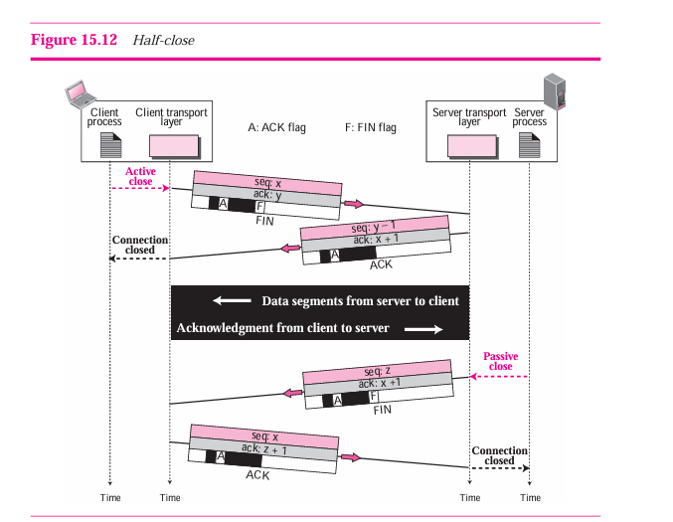

5) [A ] a DNS client is looking for the name of the computer with IP address 132.1.17.8. Show the query message. Also show the response message sent by the server to this query. Encapsulate the query and response message in a UDP user datagram 05 marks
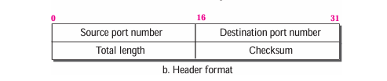
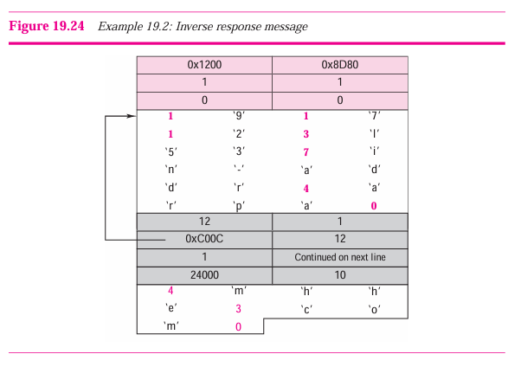
[B.] Consider distributing a file of F = 20 Gbits to N peers. The server has an upload rate of us = 30 Mbps, and each peer has a download rate of di = 2 Mbps and an upload rate of u. For N = 10, 100, and 1,000 and u = 300 Kbps, 700 Kbps, and 2 Mbps, prepare a chart giving the minimum distribution time for each of the combinations of N and u for both client-server distribution and P2P distribution. 04 marks
[C.] How does SMTP mark the end of a message body? How about HTTP? Can HTTP use the same method as SMTP to mark the end of a message body? Explain. (03 marks)
১. SMTP (Simple Mail Transfer Protocol)
SMTP-তে মেসেজ বডির শেষ বোঝাতে ব্যবহার করা হয়:
<CRLF>.<CRLF>
মানে: এক লাইনে শুধু ডট (.) থাকলেই সার্ভার বুঝবে “মেসেজ শেষ।”
উদাহরণ:
DATA
হ্যালো Bob,
কেমন আছো?

.
QUIT

২. HTTP (HyperText Transfer Protocol)
HTTP-তে মেসেজ বডির শেষ বোঝানো হয় header information বা connection দিয়ে।
ডট ব্যবহার করা হয় না।
HTTP-তে ৩টি পদ্ধতি আছে:
- Content-Length → মেসেজ বডির সাইজ দিয়ে বোঝায় কত বাইট পাঠানো হবে।
- Chunked Transfer Encoding → ডেটা ছোট ছোট অংশে পাঠানো হয়, শেষ অংশের সাইজ 0 থাকে।
- Connection Close → সার্ভার TCP connection বন্ধ করলে বডি শেষ বোঝায়।

৩. HTTP কি SMTP-এর পদ্ধতি ব্যবহার করতে পারে?
❌ না।
কারণ HTTP-তে ছবি, ভিডিও বা বাইনারি ডেটা থাকতে পারে।
সেই ডেটার ভিতরে <CRLF>.<CRLF> থাকতে পারে, তাই এটি ভুল বোঝাতে পারে।

সংক্ষেপে তুলনা:
প্রোটোকল | মেসেজ শেষ বোঝানোর পদ্ধতি | HTTP কি ব্যবহার করতে পারে? | কারণ
SMTP | <CRLF>.<CRLF> (লাইনে শুধু ডট) | ❌ না | বাইনারি ডেটার ভিতরও ডট থাকতে পারে
HTTP | Content-Length, Chunked, বা Connection Close | ✅ হ্যাঁ | সব ধরনের ডেটার জন্য নিরাপদ

[D.] What is the function of MIME? A sender sends a JPEG message. Show the MIME header. 02 marks

🌐 Function of MIME (Multipurpose Internet Mail Extensions):
MIME (Multipurpose Internet Mail Extensions) is an extension of the SMTP (Simple Mail Transfer Protocol) that allows e-mail messages to include not just plain ASCII text, but also other content types such as:
- Images (JPEG, PNG, GIF, etc.)
- Audio and video files
- Application files (PDF, DOC, ZIP, etc.)
- Text in non-ASCII character sets (Unicode, UTF-8, etc.)
👉 In short: MIME enables email to carry multimedia content and attachments, not just plain text.

🧩 How MIME Works:
When a user attaches a non-text file (e.g., image, audio, video, document), the email client encodes the data (using Base64 or Quoted-Printable) and adds MIME headers to specify:
- The type of content (Content-Type)
- The encoding scheme (Content-Transfer-Encoding)
- The file disposition or name (Content-Disposition)

📷 Example: MIME Header for a JPEG Image
Suppose Alice sends a JPEG image called photo.jpg.
The MIME header would look like this:
MIME-Version: 1.0
Content-Type: image/jpeg; name="photo.jpg"
Content-Transfer-Encoding: base64
Content-Disposition: attachment; filename="photo.jpg"
Explanation:
- MIME-Version: 1.0 → Indicates MIME is being used.
- Content-Type: image/jpeg; name="photo.jpg" → Specifies the file type is a JPEG image.
- Content-Transfer-Encoding: base64 → The binary data is encoded into Base64 for safe transmission via SMTP.
- Content-Disposition: attachment; filename="photo.jpg" → Tells the mail client to treat it as a downloadable attachment.

6
[A.] Obtain the HTTP/1.1 specification (RFC 2616). Answer the following questions: 05 marks
i. Explain the mechanism used for signaling between the client and server to indicate that a persistant connection is being closed. Can the client, the server, or both signal the close. Of a connection?
Connection: close
This signals that the connection will be closed once the transaction ends.
✔️ Both the client and the server can signal the closing of a connection.

ii) What encryption services are provided by HTTP?
HTTP itself does not provide any encryption services. It is a plaintext protocol. If encryption or security is required, HTTP is combined with SSL/TLS, which is then known as HTTPS. So, HTTP alone has no built-in encryption.

iii) Can a client open three or more simultaneous connections with a given server?
Answer:
According to RFC 2616, a client should not open more than two simultaneous connections per server. This rule was introduced to improve performance while avoiding congestion on the Internet.
✔️ Therefore, opening three or more simultaneous connections is not allowed under the HTTP/1.1 specification.

iv) Either a server or a client may close a transport connection between them if either one detects the connection has been idle for some time. Is it possible that one side starts closing a connection while the other side is transmitting data via this connection? Explain.
Yes, it is possible. Since HTTP runs over TCP, a connection can be half-closed. If one side decides to close an idle connection while the other side is still sending data, the transmission may be interrupted. This can lead to data loss or a reset if the closure is not properly synchronized.
✔️ To avoid such issues, RFC 2616 recommends using timeouts and careful connection management (e.g., keep-alive timeout).
[B.] Why do we need an RRQ or WRQ message in(TFTP but not in FTP? Show the encapsulation of an RRQ message and a WRQ message in separate UDP user datagram. Assume the file name is "Report" and the mode is ASCII. What are the size of UDP datagrams? 04 marks
[C.] Consider a DASH system for which there are N video versions (at N different rates and qualities) and N audio versions (at N different rates and qualities). Suppose we want to allow the player to choose at any time any of the N video versions and any of the N audio versions. 03 marks
i) If we create files so that the audio is mixed in with the video, so server sends only one media stream at given time, how many files will the server need to store (each a different URL)?
Question a:
Audio এবং video mix করে single stream করলে server কতগুলো file store করবে?
Answer:
- N video versions × N audio versions
Files needed=N×N

ii) If the server instead sends the audio and video streams separately and has the client synchronize the streams, how many files will the server need to store?
Question b:
Audio এবং video আলাদা stream হলে?
Answer:
- Server শুধু N video + N audio files store করবে
Files needed=N+N=2N

[D.] What is the Apache Web server? How much does it cost? What functionality does it currently have? 02 marks
উত্তর:
- কি: Apache HTTP Server হলো একটি জনপ্রিয় open-source Web server।
- দাম: Free, open-source।
- Functionality:
  - Static এবং dynamic web page serve করতে পারে।
  - বিভিন্ন modules support করে (PHP, SSL, authentication, URL rewriting)।
  - Logging, virtual hosts, load balancing করতে পারে।
  - Cross-platform support (Linux, Windows, macOS)।

Previous Question 19 -20

Question 1

[A] Queuing Delay in Router Buffer 04 marks
Consider the queuing delay in a router buffer, where a packet experiences a delay as it waits to be transmitted onto the link.
The length of the queuing delay of a specific packet depends on the number of earlier-arriving packets that are queued and waiting for transmission.
If the queue is empty and no other packet is currently being transmitted, then the packet’s queuing delay will be zero.
However, if the traffic is heavy and many other packets are waiting, the queuing delay will be long.
Assume:
- Constant transmission rate, R = 300000 bps
- Constant packet length, L = 4600 bits
- a = average rate of packets/second
- Traffic intensity, I = La / R
- Queuing delay, = I × (L/R) × (1 / (1 - I)), for I < 1
Questions:
i. In practice, does the queuing delay tend to vary a lot? (Answer with Yes or No and explain why.)
ii. Assuming that a = 28, what is the queuing delay?
iii. Assuming the router’s buffer is infinite, the queuing delay is 0.4357 ms, and 1218 packets arrive. How many packets will be in the buffer 1 second later?
iv. If the buffer has a maximum size of 563 packets, how many of the 1218 packets would be dropped upon arrival from the previous question?

[B] 03 marks
Some content providers have created their own networks.
Describe Google’s network.
What motivates content providers to create such networks?

[C] 04 marks + 03 marks
i. What is an application-layer message, a transport-layer segment, a network-layer datagram, and a link-layer frame?
ii. HFC, DSL, and FTTH are all used for residential access.
For each of these access technologies:
- Provide a range of transmission rates
- Comment on whether the transmission rate is shared or dedicated
iii. Consider sending real-time voice from Host A to Host B over a packet-switched network (VoIP).
- Host A converts analog voice into a 64 kbps bit stream on the fly.
- Host A groups the bits into 56-byte packets.
- There is one link between Hosts A and B; its transmission rate is 10 Mbps and its propagation delay is 10 msec.
As soon as Host A gathers a packet, it sends it to Host B.
As soon as Host B receives an entire packet, it converts the bits back to analog.
Question:
How much time elapses from the time a bit is created (from the original analog signal at Host A) until the bit is decoded (as part of the analog signal at Host B)?

Question 2

[A] 03 marks
“For the proper operation of CIDR, three restrictions need to be applied to the allocated block.”
Justify this statement.
ঠিক আছে, ধাপে ধাপে সহজভাবে বোঝাই।

Statement:
“For the proper operation of CIDR, three restrictions need to be applied to the allocated block.”
Justification:
CIDR (Classless Inter-Domain Routing) কাজ করার জন্য allocated IP block-এর কিছু নিয়ম মেনে চলা প্রয়োজন। মূলত ৩টি restriction আছে:

1️⃣ Block must be a power-of-2 size
- CIDR ব্লক size = 2^n ঠিকানা
- উদাহরণ: /24 = 2^8 = 256 addresses
- কারণ CIDR subnetting এবং supernetting log₂ arithmetic ব্যবহার করে
- যদি ঠিকানার সংখ্যা power-of-2 না হয় → network calculations ভুল হবে

2️⃣ Block must be contiguous
- Allocated block-এর ঠিকানাগুলো 连续 (continuous) হতে হবে
- উদাহরণ: 192.168.1.0–192.168.1.255 → contiguous
- Discontinuous addresses দিলে CIDR aggregation বা prefix calculation সম্ভব হবে না

3️⃣ Block must be aligned with the prefix
- প্রথম ঠিকানা = multiple of block size
- উদাহরণ: /24 block → first IP address last octet = 0
- অন্যভাবে বললে, network address = (block size)-এর multiple
- যদি aligned না হয় → routing table-এ aggregation এবং summarization সমস্যা হবে

Summary Table
Restriction | Reason
Power-of-2 size | CIDR uses powers of 2 for subnetting and supernetting
Contiguous addresses | Required for proper aggregation and route summarization
Prefix-aligned block | First address must match network boundary for correct routing

✅ Sohoje:
CIDR ঠিকভাবে কাজ করতে হলে block size, continuity এবং alignment ঠিক থাকতে হবে।
না হলে routing aggregation, prefix calculations, এবং network summarization ভুল হবে।

[B] 04 marks
An organization is granted the block 130.34.12.64/26.
The organization needs four subnetworks, each with an equal number of hosts.
Tasks:
- Design the subnetworks
- Find the information about each network (e.g., network address, range, broadcast address)

[C] 05 marks
An ISP is granted a block of addresses starting with 150.80.0.0/16.
The ISP wants to distribute these blocks to 2600 customers as follows:
i. The first group has 200 medium-size businesses, each needing approximately 128 addresses.
ii. The second group has 400 small businesses, each needing approximately 16 addresses.
iii. The third group has 2000 households, each needing 4 addresses.
Tasks:
- Design the sub-blocks and give the slash notation for each sub-block.
- Find out how many addresses are still available after these allocations.

[D] 02 marks
“Four levels of addresses are used in an internet employing the TCP/IP protocols, and each address is related to one layer in the TCP/IP architecture.”
Justify this statement.

1️⃣ TCP/IP Architecture Overview
TCP/IP এর মূল চারটি লেয়ার:
Layer | Address Type | Example
Application Layer | Application address / Port number | HTTP: 80, FTP: 21
Transport Layer | Transport address / Port number | TCP/UDP ports (e.g., 1024–65535)
Network Layer | Network address / IP address | IPv4: 192.168.1.1, IPv6: 2001:db8::1
Link (or Data Link) Layer | Physical/Hardware address | MAC address: 00:1A:2B:3C:4D:5E

Question : 03
(A) i. You have an interface on a router with the IP address 192.168.192.10/29.
What is the broadcast address the hosts will use on this LAN?
ii. What is the last valid host on the subnetwork 165.21.80.128/26?
iii. In fixed-length subnetting, find the number of 1’s that must be added to the mask if the number of desired subnets will be 2 and 122. 06 marks
চলো ধাপে ধাপে বাংলা ভাষায় এবং সহজভাবে করি।

(A) i. Interface: 192.168.192.10/29
Step 1: Find subnet mask
- /29 → subnet mask = 255.255.255.248
- হোস্ট-বিট = 32−29 = 3
- Number of addresses in subnet = 2^3 = 8
Step 2: Find network address
- Network address = IP AND Subnet mask
192.168.192.10 → 11000000.10101000.11000000.00001010
Subnet mask /29 → 11111111.11111111.11111111.11111000
Bitwise AND → 11000000.10101000.11000000.00001000 → 192.168.192.8
Step 3: Find broadcast address
- Broadcast = Network address + Number of addresses − 1
192.168.192.8 + 8 − 1 = 192.168.192.15
✅ Answer: 192.168.192.15

(A) ii. Last valid host of 165.21.80.128/26
Step 1: /26 subnet mask
- /26 → subnet mask = 255.255.255.192
- Host bits = 6 → addresses per subnet = 2^6 = 64
Step 2: Network & broadcast addresses
- Network address = 165.21.80.128
- Broadcast address = Network + 64 − 1 = 165.21.80.191
Step 3: Last valid host
- Last host = Broadcast − 1 = 165.21.80.190
✅ Answer: 165.21.80.190

(A) iii. Fixed-length subnetting: number of 1’s to add

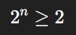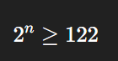
Case 1: 2 subnets
- n = log₂(2) = 1
- Add 1 bit to subnet mask
Case 2: 122 subnets
- n = log₂(122) ≈ 6.93 → round up → 7
- Add 7 bits to subnet mask
✅ Answer:
- 2 subnets → add 1 bit
- 122 subnets → add 7 bits

[B]
Construct the least-cost-path tree by tracing predecessor nodes.
Also find out the resulting least-cost-path tree from node u, and show the resulting forwarding table in u. 05 marks
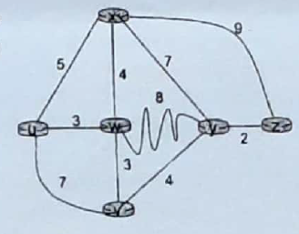

[C] 03 marks
i. When the algorithm converges, what are the distance vectors from router Y to all routers?
Write your answer as: u, v, w, x, y.
ii. What are the initial distance vectors for router W?
Write your answer as: u, v, w, x, y.
If a distance is ∞ (infinity), write ‘x’.
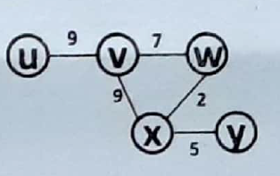

Question 4

[A] TCP Connection and Communication 05 marks
TCP opens a connection using an Initial Sequence Number (ISN) of 14,534.
The other party opens the connection with an ISN of 21,732.
i. Show the three TCP segments during the connection establishment.
ii. Show the contents of the segments during data transmission if:
- The initiator sends a segment containing the message “Hello dear customer.”
- The other party replies with a segment containing “Hi there seller.”
iii. Show the contents of the segments during the connection termination.

[B] UDP Header Analysis 04 marks
The following is a dump of a UDP header in hexadecimal format:
CB84 000D 001C 001C
i. What is the source port number?
ii. What is the destination port number?
iii. What is the total length of the user datagram?
iv. What is the length of the data?
v. Is the packet directed from a client to a server or vice versa?
vi. What is the client process?
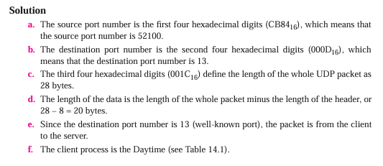

[C] TCP Window Update 03 marks
A TCP connection is using a window size of 10,000 bytes, and the previous acknowledgment number was 22,001.
It receives a segment with acknowledgment number 24,001 and window size advertisement of 12,000.
Task:
Draw a diagram to show the situation of the window before and after the update.

🧩 প্রশ্নের মূল তথ্য
- আগের Acknowledgment Number (AckNo) = 22,001
👉 অর্থাৎ, byte 22,000 পর্যন্ত সঠিকভাবে পাওয়া গেছে।
- আগের Window Size = 10,000 bytes
👉 মানে, sender একসাথে সর্বোচ্চ 10,000 byte পাঠাতে পারবে, অর্থাৎ window = [22,001 → 32,000]।
- নতুন Acknowledgment Number = 24,001
👉 মানে, byte 22,001 → 24,000 পর্যন্ত পাওয়া গেছে।
- নতুন Window Size = 12,000 bytes

🔹 Step 1: Window-এর ধারণা (Before)
অবস্থান | মানে
Last Acknowledged Byte = 22,000 | যতদূর পর্যন্ত receiver নিশ্চিত করেছে
Window Size = 10,000 bytes | sender একসাথে 10,000 byte পাঠাতে পারে
Send Window Range = [22,001 → 32,000] | পাঠানোর অনুমোদিত range

🔹 Step 2: New Acknowledgment আসার পর
Receiver এখন জানাচ্ছে:
- "আমি 24,000 byte পর্যন্ত পেয়ে গেছি"
- "এখন আমার নতুন window size = 12,000 bytes"
তাহলে নতুন Send Window হবে:
অবস্থান | মানে
New ACKed Byte = 24,000
New Window Size = 12,000 bytes
New Send Window Range = [24,001 → 36,000]
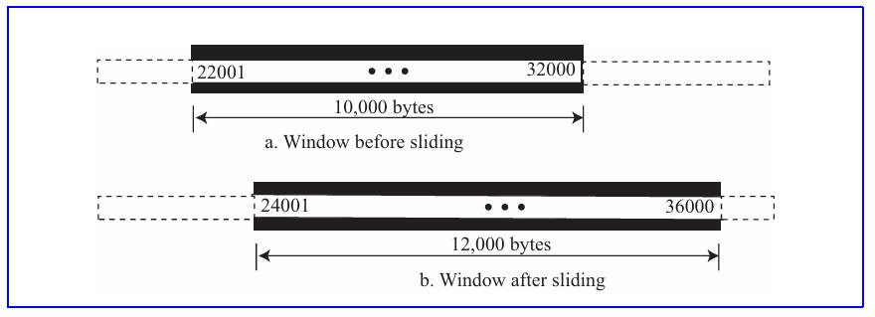

[D] Suppose you wanted to do a transaction from a remote client to a server as fast as possible.
Would you use UDP or TCP?Explain why. 02 marks
If you want to perform a transaction from a remote client to a server as fast as possible, you would generally use UDP (User Datagram Protocol). Here's why:

UDP (User Datagram Protocol)
- Faster: UDP is a connectionless protocol, meaning it doesn’t establish a connection before sending data and doesn't require acknowledgment for every packet sent. This reduces the overhead, making it faster.
- No Retransmission/Guarantees: UDP doesn't guarantee reliable delivery, which means that if some packets are lost, it won't attempt to resend them. This helps reduce latency, which is beneficial for speed but comes at the cost of reliability.
- Lower Overhead: Since UDP doesn’t have the overhead of connection management (like establishing connections, maintaining state, or acknowledgment), it can transfer data much more quickly.

TCP (Transmission Control Protocol)
- Reliable, but slower: TCP is a connection-oriented protocol, meaning it requires handshakes to establish a connection before transmitting data. It also ensures reliable data transfer through acknowledgments and retransmissions in case of packet loss. These features, while ensuring data integrity, add overhead and can slow down the transaction speed.

Why UDP is Better for Speed
- Less overhead: TCP has more control mechanisms like flow control, error checking, and congestion control. These mechanisms, while useful for reliability, slow down the transmission speed. UDP, on the other hand, skips these steps to ensure the fastest transmission.
- Suitable for real-time applications: In scenarios where speed is a priority (e.g., live video streaming, VoIP, or online gaming), UDP is preferred because even if some packets are lost, it doesn’t significantly affect the overall experience as much as the delays caused by retransmissions in TCP.

Question 5

[A] DNS Query and Response 05 marks
A DNS client is looking for the IP addresses corresponding to xxx.yyy.com and aaa.bbb.edu.
Tasks:
- Show the query message.
- Show the response message of the DNS server to this query if the addresses are:
  - xxx.yyy.com → 14.23.45.12
  - aaa.bbb.edu → 131.34.67.89

[B] File Distribution in Client-Server and P2P Models 04 marks
Consider distributing a file of F = 20 Gbits to N peers.
The server has an upload rate (us) = 30 Mbps, and each peer has:
- Download rate (di) = 2 Mbps
- Upload rate (u)
For N = 10, 100, and 1,000 and u = 300 Kbps, 700 Kbps, and 2 Mbps,
prepare a chart showing the minimum distribution time for each combination of N and u for both:
- Client-Server distribution
- P2P distribution

[C] Question:
How are DASH and DNS used to direct a user's request to the CDN server? Explain the steps with proper illustration. 03 marks

CDN Operation (কাজের ধাপ)
চলুন একটি উদাহরণে দেখি 👇
ধরো, NetCinema নামের একটি কোম্পানি তার ভিডিও সার্ভ করার জন্য KingCDN ব্যবহার করছে।
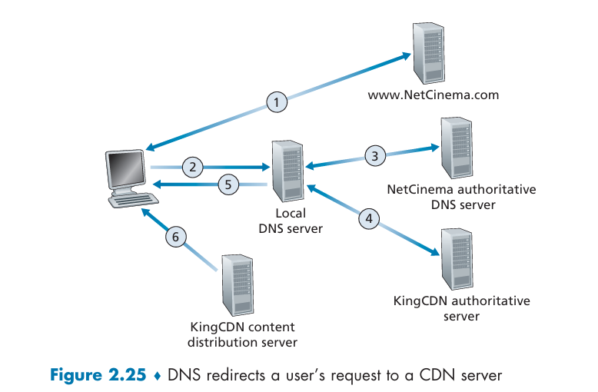

🔢 ধাপে ধাপে প্রক্রিয়া:
- ব্যবহারকারী NetCinema-এর ওয়েব পেজে যায়।
- যখন সে ভিডিও লিঙ্কে ক্লিক করে → http://video.netcinema.com/6Y7B23V,
তখন তার কম্পিউটার DNS query পাঠায় video.netcinema.com-এর জন্য।
- NetCinema-এর authoritative DNS server দেখে যে এটি ভিডিও ডোমেইন →
এটি রিকোয়েস্টটি KingCDN-এ পাঠিয়ে দেয়
এবং রিটার্ন করে a1105.kingcdn.com নামটি।
- এখন রিকোয়েস্ট KingCDN-এর DNS সিস্টেমে প্রবেশ করে।
KingCDN ক্লায়েন্টের অবস্থান অনুযায়ী একটি উপযুক্ত সার্ভারের IP address দেয়।
- এই IP address ব্যবহারকারীর কম্পিউটারে ফিরে আসে।
- ব্যবহারকারী সেই সার্ভারে সরাসরি TCP কানেকশন স্থাপন করে
এবং ভিডিওর জন্য HTTP GET request পাঠায়।
(যদি DASH ব্যবহার হয়, আগে একটি manifest file পাঠানো হয়।)

[D] Encoding 02 marks
Encode the following message in quoted-printable format:
01010111 00001111 11110000 10101111 01110001 01010100
আমাদের মূল ডেটা:
01010111 00001111 11110000 10101111 01110001 01010100

1️⃣ সব ৮-bit একত্রে লিখে দেই
010101110000111111110000101011110111000101010100
মোট ৪৮ bit ✅

2️⃣ ৬-bit করে ভাগ করি
010101 110000 111111 110000 101011 110111 000101 010100
দেখো—এখানে প্রতিটি গ্রুপ ৬-bit করে নিখুঁত হয়েছে (কোনও padding দরকার হয়নি)।

3️⃣ প্রতিটা ৬-bit → Decimal
Bits | Decimal
010101 | 21
110000 | 48
111111 | 63
110000 | 48
101011 | 43
110111 | 55
000101 | 5
010100 | 20

4️⃣ Base64 table অনুযায়ী character mapping
Decimal | Character
21 | V
48 | w
63 | /
48 | w
43 | r
55 | 3
5 | F
20 | U

✅ Final Base64 encoding:
Vw/​wr3FU

Question 6

[A] HTTP GET Message Analysis 05 marks
Consider the following string of ASCII characters that were captured by Wireshark when the browser sent an HTTP GET message.
The characters <cr><lf> represent carriage return and line-feed characters.

Captured HTTP Request:
GET /cs453/index.html HTTP/1.1<cr><lf>
Host: gaia.cs.umass.edu<cr><lf>
User-Agent: Mozilla/5.0 (Windows; U; Windows NT 5.1; en-US; rv:1.7.2) Gecko/20040804 Netscape/7.2 (ax)<cr><lf>
Accept: text/xml, application/xml, application/xhtml+xml, text/html;q=0.9, text/plain;q=0.8, image/png, */*;q=0.5<cr><lf>
Accept-Language: en-us,en;q=0.5<cr><lf>
Accept-Encoding: zip, deflate<cr><lf>
Accept-Charset: ISO-8859-1, utf-8;q=0.7, *;q=0.7<cr><lf>
Keep-Alive: 300<cr><lf>
Connection: keep-alive<cr><lf><cr><lf>

Questions:
  - What is the URL of the document requested by the browser?
ii. What version of HTTP is the browser running?
iii. Does the browser request a non-persistent or a persistent connection?
iv. What is the IP address of the host on which the browser is running?
v. What type of browser initiates this message?
vi. Why is the browser type needed in an HTTP request message?
✅ Summary of Answers
Question | Answer
i | http://gaia.cs.umass.edu/cs453/index.html
ii | HTTP/1.1
iii | Persistent connection (keep-alive)
iv | Source IP of host (from Wireshark capture)
v | Netscape 7.2
vi | Browser type needed for content negotiation, optimization, analytics

[B] HTTP Server Response Analysis 04 marks
The text below shows the reply sent from the server in response to the HTTP GET message above.
Answer the following questions, indicating where in the message you find the answer.

Captured HTTP Response:
HTTP/1.1 200 OK<cr><lf>
Date: Tue, 07 Mar 2008 12:39:45 GMT<cr><lf>
Server: Apache/2.0.52 (Fedora)<cr><lf>
Last-Modified: Sat, 10 Dec 2005 18:27:46 GMT<cr><lf>
ETag: "526c3-f22-3874a88a4c80"<cr><lf>
Accept-Ranges: bytes<cr><lf>
Content-Length: 3874<cr><lf>
Keep-Alive: timeout=max=100<cr><lf>
Connection: Keep-Alive<cr><lf>
Content-Type: text/html; charset=ISO-8859-1<cr><lf><cr><lf>
<!DOCTYPE html PUBLIC "-//W3C//DTD HTML 4.0 Transitional//EN"><lf>
<html><lf><head><lf>
<meta http-equiv="Content-Type" content="text/html; charset=iso-8859-1"><lf>
<meta name="GENERATOR" content="Mozilla/4.79 [en] (Windows NT 5.0; U) Netscape"><lf>
<title>CMPSCI 453/591/NTU-ST550A Spring 2005 homepage</title><lf>
</head><lf>
<much more document text follows here...>

Questions:
i. Was the server able to successfully find the document or not?
What time was the document reply provided?
ii. When was the document last modified?
iii. How many bytes are there in the document being returned?
iv. What are the first 5 bytes of the document being returned?
v. Did the server agree to a persistent connection?

Question | Answer | Header Reference
i | Document found; Reply at Tue, 07 Mar 2008 12:39:45 GMT | Status line + Date
ii | Sat, 10 Dec 2005 18:27:46 GMT | Last-Modified
iii | 3874 bytes | Content-Length
iv | < ! D O C | Start of document body
v | Persistent connection agreed | Keep-Alive & Connection

[C] Email Transmission via Web Servers 03 marks
What will happen when both sender and receiver use web servers to transfer email, but not necessarily the same server?Illustrate the scenario with a diagram.
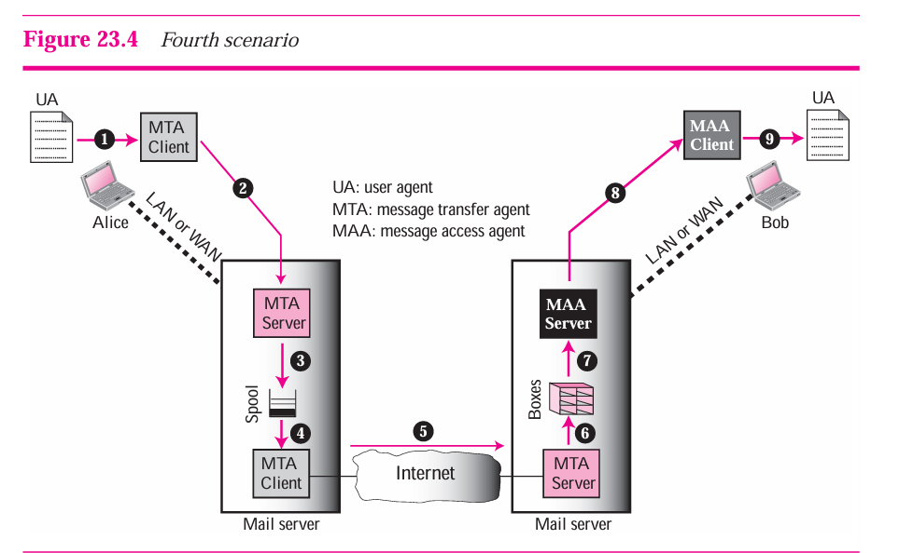

[D] Comparison 02 marks
Compare the working principles of YouTube and Netflix.
